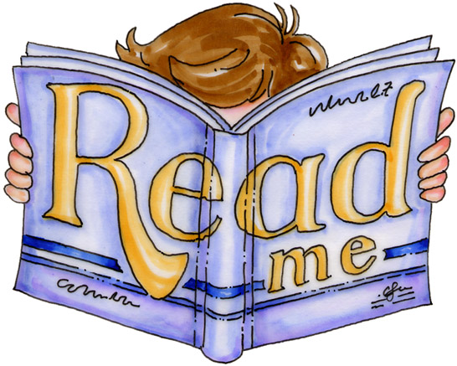
Name__________

High
Frequency
Words

List 1
List 2
List 3

List 5
List 6
List 7
List 8
List 9
List 10
List 11
List 12
List 13
List 14
List 15
List 16
List 17
List 18
List 19
List 20
List 1
about____
be____
can____
did____
for____
go____
had____
he____
is____
me____
not____
of____
said____
the____
up____
List 2
and____
but____
come____
at____
eat____
get____
has____
in____
like____
see____
they____
us____
we____
you____
are____
List 3
all____
by____
down____
from____
give____
have____
it____
little____
make____
this____
very____
was____
your____
as____
do____
List 4
any____
good____
her____
much____
new____
on____
put____
that____
were____
after____
before____
here____
how____
just____
long____
List 5
again____
him____
day____
give____
here____
been____
out____
she____
to____
what____
my____
then____
will____
her____
one____
List 6
boy____
an____
his____
man____
or____
them____
with____
if____
no____
old____
so____
two____
when____
many____
three____
List 7
there____
some____
our____
who____
take____
other____
know____
their____
which____
would____
am____
back____
work____
call____
find____
List 8
got____
home____
into____
let____
made____
name____
over____
play____
ran____
saw____
upon____
want____
away____
big____
came____
List 9
look____
must____
run____
say____
too____
way____
box____
could____
first____
last____
more____
next____
open____
read____
soon____
List 10
tell____
use____
why____
another____
best____
color____
each____
found____
girl____
house____
live____
may____
never____
such____
these____
List 11
under____
where____
also____
because____
dear____
end____
friend____
high____
kind____
left____
most____
own____
pretty____
red____
should____
List 12
thing____
until____
wish____
ball____
ear____
far____
hand____
leave____
may____
near____
only____
people____
shall____
think____
white____
List 13
year____
book____
four____
men____
please____
seem____
tree____
while____
bring____
morning____
night____
school____
than___
mother____
stand____
List 14
better____
sure____
both____
along____
car____
didn’t____
every____
fall____
gave____
happy____
jump____
keep____
letter____
might____
now____
List 15
off____
pair____
ride____
same____
thank____
walk____
yellow____
always____
bed____
carry____
does____
eight____
fast____
goes____
hard____
List 16
longer____
money____
once____
part____
round____
second____
those____
warm____
yes____
anything____
buy____
clean____
don’t____
eyes____
face____
List 17
green____
head____
love____
o’clock____
seven____
third____
wash____
yesterday____
around____
close____
door____
fine____
grow____
hear____
myself____
List 18
order____
round____
show____
today____
water____
ask____
brown____
clothes____
dress____
early____
fire____
help____
sing____
took____
woman____
List 19
ate____
coat____
fly____
hold____
sleep____
town____
write____
cold____
food____
hope____
small____
try___
full____
sister____
turn____
List 20
funny____
start____
thought____
easy____
throw____
lazy____
ugly____
though____
brother____
father____
above____
among____
ago____
beautiful____
wrong____

